
Request for Quotation (RFQ) for Goods
Reference No.: APA30RFQ292
Provision of hygiene products that are essential for women’s dignified livelihood

30 November 2018
Dear Sir/Madam,
Subject: Request for Quotation (RFQ) for the provision of hygiene products that are essential for women’s dignified livelihood and their participation in community and household activities

- The United Nations Entity for Gender Equality and the Empowerment of Women (UN Women) is seeking quotation(s) for the procurement of hygiene products as described in the annex I to this request for quotation.

- In order to prepare a responsive quotation, you must carefully review, and understand the contents of the following documents:

  - This Invitation letter and Quotation Instruction Sheet (QIS)
  - Detailed Technical Specifications of the Goods (Annex 1)
  - Quotation Submission Form and Quotation Format (Annex 2)
  - UN Women General Conditions of Contract (Annex 3)
  - Voluntary Agreement (Annex 4)
  - Model Form of Contract (Annex 5)
  - Eligibility Criteria (Annex 6)

- Quotations submitted by email must be limited to a maximum of 10 MB, virus-free or corrupted contents to avoid rejection, and no more than 3 email transmissions.

- A contract may be awarded to the supplier having submitted the quotation representing the best value for money, i.e. lowest-priced technically-compliant of the proposed offers.

- At the time of the contract award, UN Women reserves the right to vary the quantity of goods by up to a maximum of twenty five percent (25%) of the total offer without any change in the unit price or other terms and conditions

- It is UN Women’s intention to issue the contract as presented herein the RFQ documents. Therefore, offerors should ensure any due diligence regarding the legal review and ability to be compliant to all contract terms and conditions is undertaken prior to the submission of your quotation. Submission of a quotation will be confirmation of accepting UN Women General Conditions of Contract included herein.

- In the case two (2) quotations are evaluated and found to be the same ranking in terms of technical qualification and price, UN Women will award contract to the company that is either women-owned or has a majority women employed. This is in support of UN Women’s core mandate. In the case that both companies are women-owned or have a majority women employed, UN Women will request best and final offer from both suppliers and shall make a final comparison of the competing suppliers.

- UN Women reserves the right to accept or reject any quotation, and to cancel the process and reject all quotations at any time prior to the award of contract without thereby incurring any liability to the suppliers or any obligation to inform the suppliers of the grounds for such action.

- At any time prior to the deadline for the submission of quotations, UN Women may, for any reason, whether at its own initiative or in response to a clarification requested by a supplier, modify the RFQ by way of a written amendment. All suppliers that have received the RFQ shall be notified in writing of any such amendments. In order to offer suppliers reasonable time to take any such amendments into account in preparing their quotations, UN Women may, at its discretion, extend the deadline for the submission.

- The Quotation Instruction Sheet (QIS) below provides the requisite information for the Supplier as guide to respond to this request.

QUOTATION INSTRUCTION SHEET (QIS)
Instruction to Suppliers | Specific Requirements
Deadline for Submission of Quotation | Date and Time : December 11, 2018 1:00 PM  Bangkok, Thailand (for local time reference, see www.greenwichmeantime.com)  This is an absolute deadline, Quotation received after this date and time will be disqualified.
Method of Submission | ☐ Personal Delivery/ Courier mail/ Registered Mail  ☒ Electronic submission of Quotation
Address for Quotation Submission | ☒ Electronic submission of Quotation: procurement.bangkok@unwomen.org  Quotations should be submitted to the designated address by the date and time of the deadline given.
Language of the Quotation | ☒ English ☐ French ☐ Spanish  ☐ Others (pls. specify) ________________________
Quotation Currencies | MMK
Quotation Validity Period commencing after closing date of RFQ | 90 days  UN Women may exceptionally request vendor to extend quotation validity beyond the initial period indicated in the RFQ. Request will be communicated in writing.
Partial Quotes | ☐ Not permitted  ☒ Permitted
Payment Terms | ☒100% upon completion and satisfactory receipt of goods  ☐Other: [pls. specify]
Alternative Offer | ☒ Authorized  ☐ Not authorized  Alternative offer is authorized when it represents an improvement over the original offer in terms of exceeding the minimum performance parameters of the request, and is proposed by suppliers as an optional way of fulfilling the needs of the end user.
Clarifications of solicitation documents | Requests for clarification may be submitted 2 days before the submission date.  If the clarification email is different from the submission email address, do not submit any official quotes to the clarification email address. Doing so may invalidate your quote and UN Women will not be able to consider it  Clarification requests of this RFQ shall include the following subject header format: “RFQ# Request for Clarification from Vendor Name”  Suppliers shall not communicate with any other UN personnel regarding this RFQ.  UN Women shall endeavor to provide responses to clarifications in an expeditious manner, but any delay in such response shall not cause an obligation on the part of UN Women to extend the deadline date, unless UN Women deems that such an extension is justified and necessary.
Contact for requesting clarifications: | E-mail address dedicated for this purpose: procurement.bangkok@unwomen.org  Suppliers must not communicate with any other personnel of UN Women regarding this RFQ.  UN Women shall have no obligation to confirm receipt or response to query for any form of communication sent to an email other than the designated email address.
Responses to clarification requests will be binding on all Suppliers and will be distributed via: | ☐ Paper Mail  ☒ E-mail  ☐ UN Women Website  ☐Other [pls. specify]
Expected Delivery Date and Time.  Quotations can be rejected if the delivery date and time exceeds the stipulated date and time requested in the RFQ | ☐ [indicate number] days from the issuance of the Purchase Order  ☒ As per Delivery Schedule attached
Mode of Transportation | ☒Air  ☐Sea | ☒Land  ☐ Other [pls. specify]
Value Added Tax on Price Quotation | ☐Must be inclusive of VAT and other applicable indirect taxes  ☒Must be exclusive of VAT and other applicable indirect taxes
Evaluation Criteria | Standard Eligibility Criteria are specified in Annex 6.  ☒ Technical responsiveness/Full compliance to specification requirements and lowest price  ☒ Comprehensiveness of after-sales services  ☒ Full acceptance of the UN Women General Conditions of Contract  ☒ Earliest Delivery / Shortest Lead Time  ☒ Others Has local distribution network in Myanmar
Type of Contract to be Signed | ☒ Purchase Order  ☐ Long-Term Agreement  ☐ Other Type/s of Contract [pls. specify]

- UN Women’s vendor protest procedure provides an opportunity for appeal to supplier(s) who believe that they were not treated fairly. This link provides further details regarding UN Women’s vendor protest procedures.
Suppliers, their subsidiaries, agents, intermediaries and principals must cooperate with the Office of Internal Oversight Services (OIOS) of the United Nations, UN Women Internal Audit and Investigations Group (IAIG) as well as with other investigations authorized by the Executive Director and with the UN Women Ethics Office as and when required. Such cooperation shall include, but not be limited to the following: access to all employees, representatives, agents and assignees of the supplier; as well as production of all documents requested, including financial records.
Failure to fully cooperate with investigations will be considered sufficient grounds to allow UN Women to repudiate and terminate the contract, and to debar and remove the supplier from UN Women’s list of registered suppliers.
- UN Women implements a zero tolerance on fraud and other proscribed practices, and is committed to identifying and addressing all such acts and practices against UN Women, as well as third parties involved in UN Women activities. UN Women expects its suppliers to adhere to the UN Supplier Code of Conduct found in this link: http://www.un.org/depts/ptd/pdf/conduct_english.pdf

- This letter is not to be construed in any way as an offer to contract with your organization.
Yours sincerely,
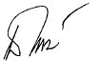
Welder Mtisi
Officer-in-Charge
Regional Office for Asia and the Pacific

ANNEX 1

SCHEDULE OF REQUIREMENTS OF GOODS
Provision of hygiene products that are essential for women’s dignified livelihood

STATEMENT OF NEED
UN Women recognizes that in order for women in the camps to live with basic diginity, hygiene kits are essential items for their needs. Without the essential items provided in the hygiene kits such as sanitary pads, they face significant barriers to participate in a range of activities - particularly those in the public sphere. In this regard, UN Women is supporting implementing partners in Rakhine to provide hygiene products to support women to fulfil women’s needs and decrease the barriers they face to actively participate in community activites. These terms of reference calls for the procurement of key items for hygiene kits, required by women beneficiaries to ensure their dignified livelihood and participation in the community activities. All items and assets should be procured and delivered and installed by 25 March, 2019.
Background
The United Nations Entity on Gender Equality and the Empowerment of Women (UN Women), grounded in the vision of equality enshrined in the Charter of the United Nations, works for the elimination of discrimination against women and girls; the empowerment of women; and the achievement of gender equality in development, human rights, humanitarian action and peace and security. At the country level, UN Women is leveraging its triple mandate in Myanmar to promote gender equality and women’s empowerment (GEWE) as central to the peacebuilding, crisis response and recovery, democratic governance, and development processes. UN Women’s economic empowerment programme seeks to increase women’s access to economic opportunities.
In Rakhine State, UN Women is implementing its women’s economic empowerment activities through a one-year (1 April 2018 to 31 March 2019) joint programme together with UNDP on “Inclusive development and empowerment of women in Rakhine state, Myanmar” in collaboration with the Government of Myanmar (GoM), the Rakhine State Government (RSG) and relevant partners. UN Women has identified two key sectors as key strategic entry points for further stimulating economic activity for women in Rakhine:
- Agriculture, particularly gender responsive evidence-based and market-oriented high-quality climate resilient rice seeds and cash crop production, through provision of agriculture inputs, agriculture business development, entrepreneurship and business development; and
- The handicraft and weaving industry with a focus on vocational skills training for handicraft development, entrepreneurship development, provision of equipment.

The women’s economic empowerment activities for this programme are implemented in four selected townships: Sittwe, Mrauk-U, Pauktaw, and Ponnagyun. The programme aims to reach approx. 16,000 direct beneficiaries while directly reaching the most marginalized women. The programme activities are implemented by Bridge Asia Japan, Finish Church Aid Consortium, Oxfam and IRRI. UN Women is providing additional support to the Department of Social Welfare (DSW) and Small Scale Industries Department (SSID) Vocational Training Centers.
UN Women recognizes that in order for women in the camps to live with basic diginity, hygiene kits are essential items for their needs. Without the essential items provided in the hygiene kits such as sanitary pads, they face significant barriers to participate in a range of activities - particularly those in the public sphere. In this regard, UN Women is supporting implementing partners in Rakhine to provide hygiene products to support women to fulfil women’s needs and decrease the barriers they face to actively participate in community activites.

Objectives of the assignment;
The objectives of the assignment is to ensure that women beneficiaries are able to participate in the all of the program activities without any barriers and live with basic dignity.

Scope of work
The scope of work will include the supply and delivery of the relevant products required as per the technical specifications attached.
Quality assurance is expected from the SUPPLIER, such that any error or low quality products shall be acted upon, or replaced accordingly at no cost to the organization. Likewise, upon final project acceptance, the SUPPLIER is required to ensure quality of the products after sales services and during the warranty period.

Items  1  2  3  4 | Qty. | Unit of Measure | Descriptions / Specifications of Goods | Delivery
 |  |  |  | Expected** Delivery Date | Location
Items  1  2  3  4 | 27,884 | Body soap  Bar (115grams) | Body soap  115 grams, individually packaged, perfumed | 22/03/2019 | Oxfam Office in Sittwe Warehouse  No (Pa-60), North San Pya, Pyi Taw Thar Ward  Sittwe Township, Rakhine State, Myanmar
Items  1  2  3  4 | 6,971 | Carbolic soap  Bar (250gram) | Carbolic soap  250g bar, not perfumed | 22/03/2019
Items  1  2  3  4 | 41,826 | Laundry soap  Bar (200grm) | Laundry soap  200g bar, Shwewah brand (or equivalent) | 22/03/2019
Items  1  2  3  4 | 13,942 | Packet of ten | Sanitary pads | 22/03/2019
Note: In case of discrepancy between unit price and total, the unit price shall prevail.

ANNEX 2

QUOTATION SUBMISSION FORMS
STATEMENT OF CONFIRMATION
[The supplier shall fill in this form with no alterations or substitutions to its format and content]

To: [insert UN Women Date: [insert date of Quotation Submission]
Address, City, Country]

We, the undersigned, declare that:
- We (representatives of this company, inclusive of any associated legal representatives) have examined the minimum requirements, terms and clauses and have no reservations to the RFQ including all annexes;
- We agree to abide by this RFQ and in accordance with the UN Women General Conditions of Contract (Annex IV) and will not request any changes to the existing terms, conditions and clauses;
- We offer to supply in conformity with the RFQ, the following [Title of goods] and undertake, if our offer is accepted, to commence and complete delivery of all goods specified in the contract within the time frame stipulated;
- We offer to supply for the sum as may be ascertained in accordance with the Quotation submitted and with the instructions under the Quotation Instruction Sheet;
- Our offer shall be valid for a period of [___] days from the date fixed for opening the RFQ, and it shall remain binding upon us and may be accepted at any time before the expiration of that period;
- We understand that UN Women is not bound to accept the lowest evaluated quotation or any other quotation that you may receive.

SIGNATURE AND CONFIRMATION OF THE RFQ
PROVIDED THAT A PURCHASE ORDER IS ISSUED BY UN WOMEN WITHIN THE QUOTATION VALIDITY PERIOD STATED ABOVE, THE UNDERSIGNED HEREBY COMMITS, SUBJECT TO THE TERMS OF SUCH PURCHASE ORDER, TO FURNISH ANY OR ALL ITEMS AT THE PRICES OFFERED AND TO DELIVER SAME TO THE DESIGNATED POINT(S) WITHIN THE DELIVERY TIME STATED ABOVE. THE UNDERSIGNED HEREBY SIGNS IN CONFIRMATION THAT THEY HAVE REVIEWED THE RFQ AND AGREE TO UN WOMEN CONTRACT MODEL AND THE GENERAL CONDITIONS OF CONTRACT.
Exact name and address of company  COMPANY NAME: __________  ADDRESS: ___  PHONE NO.:_____________________________  E-MAIL ADDRESS: ________________________ | AUTHORIZED SIGNATURE:________________  DATE: _______________________________  NAME: (TYPE OR PRINT)  FUNCTIONAL TITLE OF AUTHORIZED SIGNATORY:_____________________________  E-MAIL ADDRESS: ________________________
This quotation submission form MUST be duly completed and returned with the QUOTATION, along with confirmation that the products are in accordance with specifications and requirements of UN Women. The quotation “MUST” be submitted in the vendor’s business letterhead stationery. Failure to do so may result in disqualification of your QUOTATION.

Quotation Format

TABLE 1: Item Description and Price
UNIT PRICES (Indicate the Price & Currency of Quotation):
ITEM | DESCRIPTION | QTY. | UNIT OF MEASURE | CURRENCY (please specify):
 |  |  |  | UNIT PRICE & indicate whether DAP, FCA, CIP, CPT, and/or other (please specify) | TOTAL PRICE, (inclusive of shipping)
1.
2.
3.
4.
5.
6.
7.

TOTAL PRICES (Indicate the Price & Currency of Quotation)
TOTAL DAP, FCA, CIP, CPT, other [please specify] PRICE:
FREIGHT /INSURANCE/HANDLING COSTS:
TOTAL COST:

TABLE 2: Estimated Operating Costs (if applicable)
List of Consumable Item/s (Include fast moving parts, if any) | Estimated Average Consumption | Unit of Measure | Unit Price | Total Price per Item
TABLE 3: Compliance Requirements
Compliance Requirements : | Your Responses
Compliance Requirements : | Yes, we will comply | No, we cannot comply | Provide reasons for non-compliance
Payment terms 30 days upon receipt of invoice
Delivery Lead Time: [minimum delivery lead time]
Estimated weight/volume/dimension of the Consignment: [minimum measurements]
Country/ies Of Origin:
Validity Period of Quotation: 90
Warranty and After-Sales Requirements
- Training on operations and maintenance
- Minimum one (1) year warranty on both parts and labor
- Service unit to be provided when the purchased unit is under repair
- Brand new replacement if purchased unit is beyond repair
- Other requirements [pls. specify]

All other information that we have not provided automatically implies our full compliance with the requirements, terms and conditions of the RFQ.

UN Women will not be charged for any samples as separate line items and expects the vendor to be able to provide at least 1 sample per request for any changes requested within scope. UN Women expects any provision of samples to be part of the vendor’s business cost and inclusive of the pricing offered above. If samples are to be returned, please provide a self-addressed and stamped envelope.

ANNEX 3

UN WOMEN GENERAL CONDITIONS OF CONTRACT
The GCs can be accessed by supplier from UN W website (http://www.unwomen.org/en/about-us/procurement) or directly by clicking on the below link:
http://www.unwomen.org/~/media/commoncontent/procurement/unwomen-generalconditionsofcontract-goods-en.pdf

ANNEX 4

VOLUNTARY AGREEMENT TO PROMOTE GENDER EQUALITY
Voluntary Agreement to Promote Gender Equality and Women’s Empowerment
Between _________________________________ (Name of the Contractor)
And The United Nations Entity for Gender Equality and the Empowerment of Women
The United Nations Entity for Gender Equality and the Empowerment of Women, a composite entity of the United Nations established by the United Nations General Assembly by its resolution 64/289 of 2 July 2010 (hereinafter referred to as “UN Women”) strongly encourages (_________________________) (hereinafter referred to as the “Contractor”) to partake in achieving the following objectives:
☐ Acknowledge values & principles of gender equality (http://www.unwomen.org/en/about-us/guiding-documents) and women’s empowerment (http://weprinciples.org/Site/PrincipleOverview/);
☐ Provide information and statistical data (that relates to policies and initiatives that promote gender equality and women empowerment), upon request;
☐ Participate in dialogue with UN Women to promote gender equality and women’s empowerment in their location, industry and organization;
☐ Establish high-level corporate leadership for gender equality;
☐ Treat women and men fairly at work and respect and support human rights and nondiscrimination, including through equal pay policies;
☐ Ensure health, safety and wellbeing of all women and men workers;
☐ Promote education, training and professional development for women;
☐ Hold gender-specific trainings or courses for staff;
☐ Implement enterprise development, supply chain and marketing practices that empower women;
☐ Promote equality through community initiatives and advocacy;
☐ Measure and publicly report on progress to achieve gender equality.

On behalf of the Contractor: ____________________________
Name, Title: _____________________________,_______________________
Address: _________________________________________________________________

Signature: ______________________________________
Date: _________/___________/________
DD MM YYYY

ANNEX 5

MODEL FORM OF CONTRACT
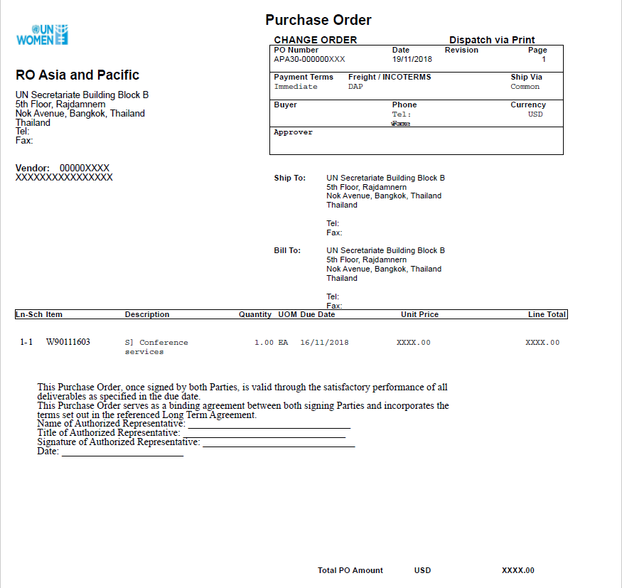

ANNEX 6

ELIGIBILITY CRITERIA
The standard eligibility criteria for suppliers wishing to engage in a contract are laid out below. Further information on doing business with UN Women/ how to become UN Women vendor can be found on UN Women’s website.

Legal Capacity: Bidders may be a private, public or government-owned legal entity or any association with legal capacity to enter into a binding Contract with the United Nations Entity for Gender Equality and the Empowerment of Women (UN Women).

Conflict of Interest: Bidders must disclose any actual or potential conflict of interest and they shall be deemed ineligible for this procurement process unless such conflict of interest is resolved in a manner acceptable to UN Women. Conflict of interest is present when:
- A Bidder has a close business or family relationship with a UN Women personnel who: (i) are directly or indirectly involved in the preparation of the bidding documents or specifications of the contract, and/or the bid evaluation process of such contract; or (ii) would be involved in the implementation or supervision of such contract;
- A Bidder is associated, or has been associated in the past, directly or indirectly, with a firm or any of its affiliates which have been engaged by UN Women to provide consulting services for the preparation of the design, specifications, Terms of Reference, and other documents to be used for the procurement of the goods, services or works required in the present procurement process;
- A Bidder has an interest in other bidders, including when they have common ownership and/or management. Bidders shall not submit more than one bid, except for alternative offers, if permitted. This will result in the disqualification of all bids in which the Bidder is involved. This includes situations where a firm is the Bidder in one bid and a sub-contractor on another; however, this does not limit the inclusion of a firm as a sub-contractor in more than one bid.
Failure to disclose any actual or potential conflict of interest may lead to the Bidder being sanctioned further by UN Women.

Ineligibility Lists: A Bidder shall not be eligible to submit an offer if and when at the time of submission, the Bidder:
- is included in the Ineligibility List, hosted by UNGM, that aggregates information disclosed by Agencies, Funds or Programs of the UN System;
- is included in the Consolidated United Nations Security Council Sanctions List, including the UN Security Council Resolution 1267/1989 list;
- is included in any other Ineligibility List from a UN Women partner and if so listed in the RFQ Instructions.
- is currently suspended from doing business with UN Women and removed from its vendor database(s).

Code of Conduct: All Bidders are expected to embrace the principles of the United Nations Supplier Code of Conduct, reflecting the core values of the Charter of the United Nations. UN Women also expects all its suppliers to adhere to the principles of the United Nations Global Compact and recommends signing up to the Womes Empowerment Principles.

If the country of origin requires Export License for the goods being procured, or other relevant documents that the country of destination may require, the supplier must submit them to UN Women if awarded the PO/contract.

